Give the examples of cultural differences in communication between countries
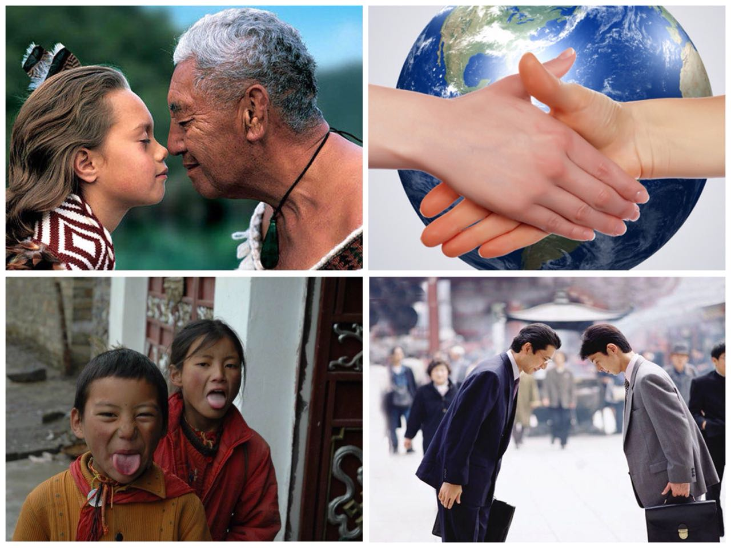

Model: Russian people usually shake hands when greeting, Japanese greet each other by bowing.

VOCABULARY Keeping in touch with foreign contacts

Do keep in touch.

I’ll keep your informed of our activities.

Do keep me informed of any new development

Perhaps I could send you more detailed information?

I’ll send you the samples as soon as possible

I’ll work on those figures you gave me and come back to you on them. | I’ll come back to you means:  I’ll contact you (not I’ll visit you)

Perhaps next time I’m in the area I could pay you a visit? | I’ll pay you a visit means:  I will visit you.

Drop me a line if anything new comes in | I’ll drop you a line means:  I will write you.

I’d like to think about what we’ve said and drop you a line.

Keep the door open. | Keep the door open means:  To make further contact possible.

Keep me in the picture! | Keep me in the picture means:  Keep me informed.

Read the common internet terms below:

Spam virus password chatroom firewall mailing list
cookie encryption hacker portal homepage browser
- Write definitions of four terms you know.
Model: browser – this is a program like Internet Explorer that makes it possible for you to look at and read documents on the Internet.

