Упражнение 61
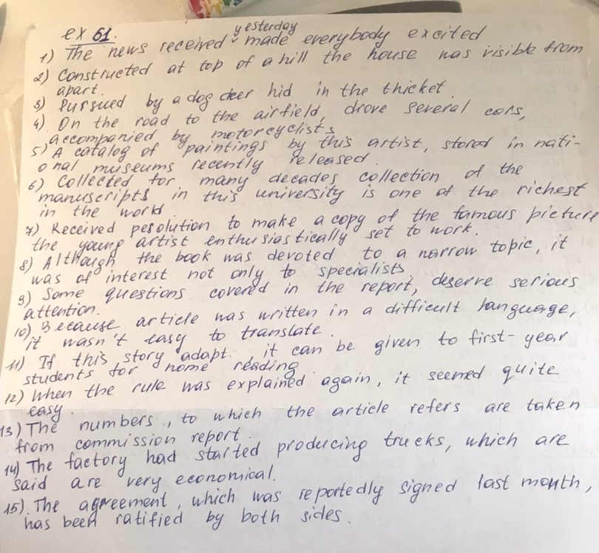
Упражнение 62
- Several lines were on the sheet of paper, written by the pencil
- If I am asked, I will tell the truth
- in the vase were a few wilted roses
- I don't like to look at caged in cell animals
- The book will be here until someone asks for it
- Her husband was a retired colonel.
- Although he was very surprised, he didn't say a word.
- Here are the new schoolbooks sent to our school
- Left alone in the dark, the child began to cry.
- Students wrote an essay about the educational system in England as it described by Dickens
- The sun had set, and the trees looked dark, as if they cut from black marble.

