VOCABULARY
1.In the boxes below are some verbs and nouns which are often found together. Match them up.
Achieve: an award
Break: something worthwhile
Make: something worthwhile, money for charity
Overcome: problems, a world record
Raise: a company, a risk, a world record
Show: an award, something worthwhile, stamina
Take: an award, a company, money for charity
Take over: problems, difficulties
Cope with : difficulties, problems
Win: something worthwhile, money for charity
2.In pairs, think of the examples of how the word combinations can be used.
Our team achieve an award yesterday.
When i was a child, I broke my grandmother's worthwhile vase.
On my birthday I was given a truly worthwhile present.
In a difficult time for us we can overcome all the problems.
Our task is to raise the company to a new level.
When I was visiting a friend of mine, he showed me his father's awards.
We forgot to take the money for charity, so we had to go back.
I will take over problem on myself because I know how to solve it.
He helped me cope with all the difficulties when I needed help.
He decided to win a worthwhile position in the ranking and eventually got the world record.
3.Look at other combinations with some of the verbs. Cross out any combinations which are not possible. Can you explain why?
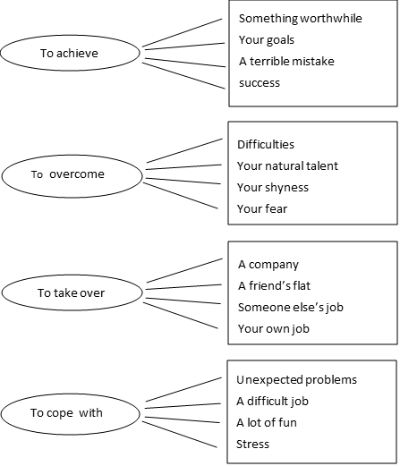

- You can only achieve something good, in a negative sense it is used rarely
- You can only overcome your shortcomings, but talent is not a shortcoming.
- This variant has not meaning of job control.
- I can say that it does not fit the meaning. You have to cope with what you don't like.
Write sentences using the word combinations
Our fund has raised a large sum of money for charity an orphanage.
My grandfather has overcome a lot of difficulties to come home alive.
He has made a lot of sacrifices in order to achieve what she wanted to marry him.
I has taken huge risks when did I start implementing this project.
I have had to cope with unexpected problems returning from vacation.
My dog has done something rather pointless when we went to the store.
She seems very modest about his achievements in the field of modeling.
At him seems to have no sense of danger he's very brave.
I have succeeded against the odds a society that doesn't respect me.
At the event he has shown a lot of dedication and stamina, so he deserved a reward.
I have achieved something worthwhile only after a lot of work.
They have got their priorities wrong that's why they lost their business.

