Гильмуллина А.А. ПЭ-1-19   
  
Summary

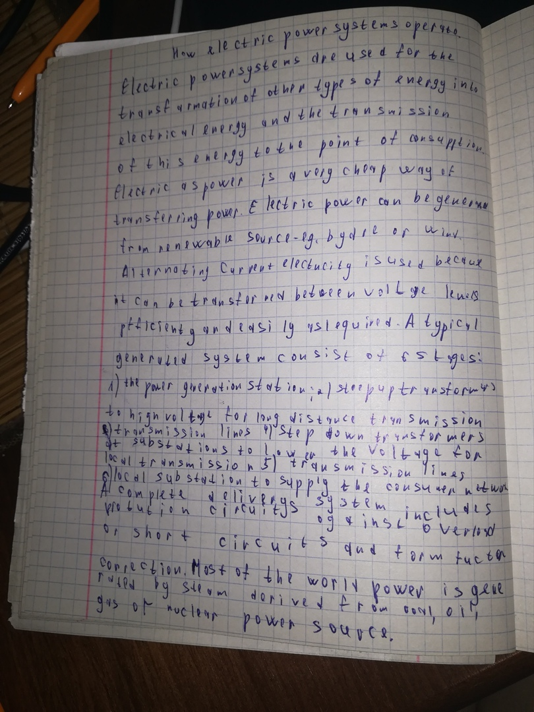

Exercise 4

1. We will attend that conference in St. Louis next month.   
2. He goes in for sports once a week.   
3. He was at the meeting yesterday.   
4. I will not wait for you next time.   
5. They did not require our help last Tuesday.   
6. Do you know the name of this girl?   
7. There were thousands of people outside during the last festival.   
8. The scientists say that the world will grow cold in 200 years.   
9. She wants to graduate from the University and to become a well-paid lawyer.   
10. They did not realize their mistake even when the accident happened.   
11. My friend always passes his examinations well.   
12. Are your parents proud of you when you show good results?   
13. There will be an important meeting here next Thursday evening.   
14. When they were young they (introduced) different methods of teaching foreign languages.   
15. Why didn't you come to see us last weekend?

Exercise 7

1. When he arrived to the village it was getting dark.

2. We watched TV when Tom entered the room.

3. A totally new control system was installedin the Underground.

4. They will complete an important research work next June.

5. When I met him he was working on his new novel.

6. Now this kind of work is organized at their laboratory.

7. Do you understand what she is saying?

8. They were having lunch when I came into the room.

9. The work is done now and soon it will be finished.

10. The plans of the next year were discussed at last meeting.

Exercise 8

1. Specialists determined the main properties of the substance this month.

2. These machines have been produced by our plant since last year.

3. The delegation will have been met by 3 o’clock tomorrow.

4. We just carried out the test successfully.

5. I have never visited this museum.

6. The plane has already left Kazan for Moscow.

7. When I came they had been tell all the important information.

8. My sister has looked through the morning newspapers for 30 minutes.

9. He had never read the books by Agatha Christie.

10. John had visited by his group mates by yesterday evening.