***Discuss:***

1. What does it mean to be the Man of Act?
2. What advice can you give to the people who want to achieve success?
3. Is leadership a natural-born talent or a learned skill?
4. What qualities does a successful leader need?
5. In what different situations do people need to work together as a group?
6. Does every group need a leader? Why/Why not?

***pLook at the photograhs***

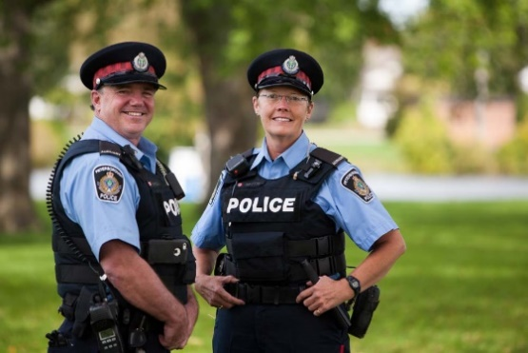



1. **Decide:**

Which would be the best place to work and why in 5 years time?

Which would be the worst place to work and why?

***Choose one of the places. Make a list of all the different jobs people do there***.

Is there a job that you would like to be good at?

***Look at the list of skills and qualities in the box.***

***Which of them are necessary for the job in your list?***

***Discuss this with your partner as in the example.***

**Example**: To be a _____ you need to have good ____skills and to be _____.

|  |  |
| --- | --- |
| Skills | Qualities |
| Computer skills  Typing skills  Driving skills  Interpersonal skills  Artistic skills  Language skills  Mathematical skills  Managerial skills  Financial skills  Cooking skills | Patient  Physically strong  Emotionally strong  Well-organised  Intelligent  Caring  Calm  quick-thinking  honest  punctual |