PC, internet, smartphone: what’s the next big technological epoch?
John Naughton

The long view suggests we’re due a new era, whether it is that of metaverses, blockchain or quantum computing
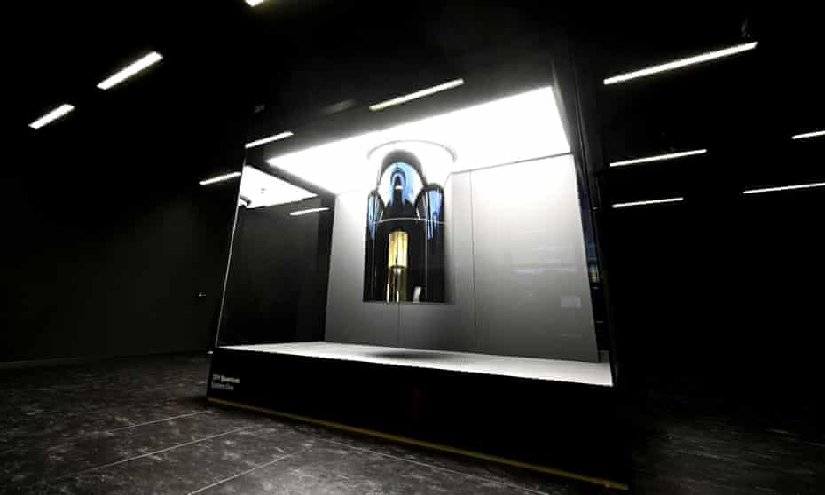
The first commercially used quantum computer, unveiled at IBM’s German HQ in June this year. Photograph: Bernd Weissbrod/dpa/AP
Sat 11 Sep 2021 16.00 BST

One of the challenges of writing about technology is how to escape from what the sociologist Michael Mann memorably called “the sociology of the last five minutes”. This is especially difficult when covering the digital tech industry because one is continually deluged with ‘new’ stuff – viral memes, shiny new products or services, Facebook scandals (a weekly staple), security breaches etc. Recent weeks, for example, have brought the industry’s enthusiasm for the idea of a “metaverse” (neatly dissected here by Alex Hern), El Salvador’s flirtation with bitcoin, endless stories about central banks and governments beginning to worry about regulating cryptocurrencies, Apple’s possible rethink of its plans to scan phones and iCloud accounts for child abuse images, umpteen ransomware attacks, antitrust suits against app stores, the Theranos trial and so on, apparently ad infinitum.
So how to break out of the fruitless syndrome identified by Prof Mann? One way is to borrow an idea from Ben Thompson, a veteran tech commentator who doesn’t suffer from it, and whose (paid) newsletter should be a mandatory daily email for any serious observer of the tech industry. Way back in 2014, he suggested that we think of the industry in terms of “epochs” – important periods or eras in the history of a field. At that point he saw three epochs in the evolution of our networked world, each defined in terms of its core technology and its “killer app”.
Epoch one in this framework was the PC era, opened in August 1981 when IBM launched its personal computer. The core technology was the machine’s open architecture and the MS-DOS (later Windows) operating system. And the killer app was the spreadsheet (which, ironically, had actually been pioneered – as VisiCalc – on the Apple II).
Epoch two was the internet era, which began 14 years after the PC epoch began, with the Netscape IPO in August 1995. The core technology (the “operating system”, if you like) was the web browser – the tool that turned the internet into something that non-geeks could understand and use – and the epoch was initially characterised by a vicious struggle to control the browser, a battle in which Microsoft destroyed Netscape and captured 90% of the market but eventually wound up facing an antitrust suit that nearly led to its breakup. In this epoch, search was the killer app and, in the end, the dominant use came to be social networking with the dominant market share being captured by Facebook.
Epoch three in Thompson’s framework – the era we’re in now – was the mobile one. It dates from January 2007 when Apple announced the iPhone and launched the smartphone revolution. Unlike the two earlier eras, there’s no single dominant operating system: instead there’s a duopoly between Apple’s iOS and Google’s Android system. The killer app is the so-called “sharing economy” (which of course is nothing of the kind), and messaging of various kinds has become the dominant communications medium. And now it looks as though this smartphone epoch is reaching its peak.
If that is indeed what’s happening, the obvious question is: what comes next? What will the fourth epoch be like? And here it’s worth borrowing an idea from another perceptive observer of these things, the novelist William Gibson, who observed that “the future is already here; it’s just not evenly distributed”. If that’s as profound as I think it is, then what we should be looking out for are things that keep bubbling up in disjointed and apparently unconnected ways, like hot lava spurts in Iceland or other geologically unstable regions.
So what can we see bubbling up in techland at the moment? If you believe the industry, metaverses (plural) – basically conceived as massive virtual-reality environments – might be a big thing. That looks to this observer like wishful thinking for psychotics. At any rate, at its extreme end, the metaverse idea is a vision of an immersive, video-game-like environment to keep wealthy humans amused in their air-conditioned caves while the planet cooks and less fortunate humans have trouble breathing. In that sense, the metaverse might just be a way of avoiding unpleasant realities. (But then, as a prominent Silicon Valley figure recently joked, maybe reality is overrated anyway.)
Two more plausible candidates for what will power future epochs are cryptography – in the sense of blockchain technology – and quantum computing. But an era in which these are dominant technologies would embody an intriguing contradiction: our current crypto tools depend on creating keys that would take conventional computers millions of years to crack. Quantum computers, though, would crack them in nanoseconds. In which case we might finally have to concede that, as a species, we’re too smart for our own good.

